Release Notes 11-06-2013

This release of Citrix Self Service Desktops is the first to support streamed desktops from PVS.

Note that the format of the configuration has changed slightly, so please follow this procedure for installation:

1. If you have installed a previous version of Self Service Desktops, first save any configuration files you have from the old installation of Self Service Desktops
2. Use Control Panel to uninstall both the Citrix Self Service Desktops Agent and the Citrix Self Service Desktops Web App
3. Install the new Citrix Self Service Desktops Agent and Citrix Self Service Desktops Web App using the provided MSI files. Note that the web app \*still\* only supports installation on the default web site (please contact me if this is a problem)
4. Re-apply your configuration to the new installation.
5. Restart the Citrix Self Service Desktops Agent

The recommended practice is to maintain the configuration only in the App.config file of the Citrix Self Service Desktops Agent; the installation guide gives you the location of this file. The Citrix Self Service Desktops Web App should be configured to acquire its configuration from the Citrix Self Service Desktops Agent. This is done using a Web.config file that contains an entry like this:

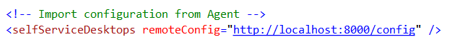

If port 8000 is not convenient for your location, you can change it in the Citrix Self Service Desktops Agent config file (and of course in the above URL)



Queries, questions bug reports: [simon.waterhouse@citrix.com](mailto:simon.waterhouse@citrix.com)